

**Our Reception Curriculum – Summer 1** 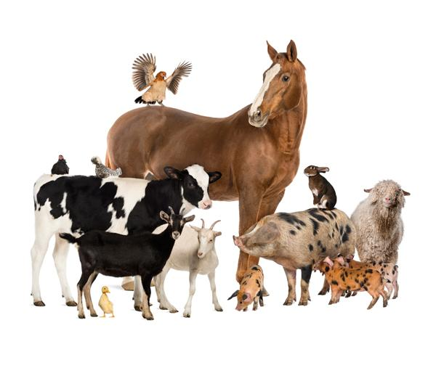

| **Topic** | **Animals** |
| --- | --- |
| **Topic Focus** | Growth and development  Staying alive  Life cycles |
| **English**  **Core Texts** | The Little Red Hen  Click, Clack, Moo  Farmer Duck |
| **Additional Texts**  **(Spine Books)** | The Very Selfish Crocodile, The Three Little Pigs, Suddenly, What will I be?, Six Dinner Sid |
| **Nursery Rhymes** | There was an old lady  Old Macdonald had a farm  Little Miss Muffet  Animal Fair  B-I-N-G-O  Hickory, dickory dock |
| **Understanding of the World** | **Farm Animals**  Growth and development  Staying alive  Life cycles  **Seasons**  Daily teaching of weather conditions using weather chart  Investigation focus 1: Life cycles |
| **Personal, Social and Emotional Wellbeing** https://lh4.googleusercontent.com/fT2AYx2BneB5xSDfxw3RfYmPwHrr2tHW9aC135X0Rs5DMrr7xMsJ68i0rFWbbsuPVG_WUwZKK256UYGtN9ax9RXrEOKnW5Gaq4zqhcIpzjxOwbJx5fXXPJkEBkJpTjcZdzJ-W-5n | Know and talk about the different factors that support their overall health and wellbeing:   * toothbrushing * sensible amounts of ‘screen time’ * having a good sleep routine * being a safe pedestrian |
| **Computing** https://lh5.googleusercontent.com/iRXxU1DnACyhzIR4Dxavlxtl1nnAG9-9-ibwwMawTsEBrUS4dIdglZaINXU1_xgkwDBNdmrZCHrW6JVvtWINusxzpuQONX-k5dLa8ZD4JOV0o8B8HjIoYDghn0MvHDX3vrjBqYLX | **Programming:** All About Instructions   * Giving simple instructions * Debugging instructions * Predictions |
| **Expressive Art & Design** | Safely use and explore a variety of materials, tools and techniques, experimenting with colour, design, texture, form and function.  Share their creations, explaining the process they have used.  Perform songs, rhymes, poems and stories with others, and (when appropriate) try to move in time with music. |
| **Physical Education** https://lh5.googleusercontent.com/y3koAJsCpi_Pe5Y2xdf7hiueKPujFd67P46n-AtQLnmLL0PmbyP4wtEp57EQEDBmIV7OYeeNwFP00Jl0VfAmC9E23vZVcIse8ZvSLmBG_ovQT3iF1b1JxzR6R4svE3RkCg_3ECbF | The children will continue to develop overall body strength, coordination, balance and agility through a range of gross and fine motor skills activities. |