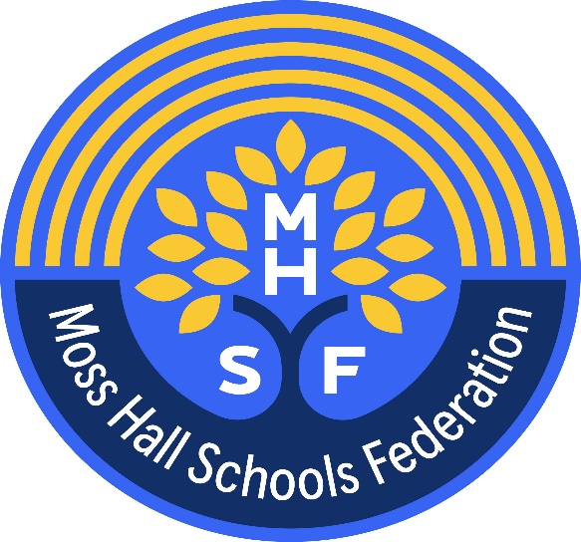

Privacy Notice

How we use governor information – Moss Hall Schools Federation

Moss Hall Infant School – Moss Hall Junior School

The categories of governor information that we collect, hold and share include:
- Personal information (such as name and address)
- Contact details
- References
- Evidence of qualifications
- Employment details
- Information about business and pecuniary interests
- Race, ethnicity, religious beliefs, sexual orientation and political opinions
- Disability and access requirement
- Right to work in UK information including references/CV, copies of identification documents and photo ID
- CCTV, access control video/systems and still photography, for safeguarding if installed on site

Why we collect and use this information
We use the governor data:

- for communication
- to comply with publication of governor information including business interests
- to comply with the law regarding data sharing
- to comply with safeguarding regulations
- Maintain effective governance
- Meet statutory obligations for publishing and sharing governor information
- Safer recruitment, as part of our safeguarding obligations towards pupils
- Equalities monitoring
- Access arrangements

The lawful basis on which we use this information
Where you have provided us with consent to use your data, you may withdraw this consent at any time. We will make this clear when requesting your consent, and explain how you go about withdrawing consent if you wish to do so. Some of the reasons listed above for collecting and using personal information about you overlap, and there may be several grounds which allow and justify our use of your data.

We collect and use governor information under
- The Education Act (various years)
- Article 6, and Article 9 (GDPR) (includes special category data)
- Article 23 GDPR (Restrictions prevention, investigation and detection of crime)
- Data Protection Act 2018 Schedule 1 Paragraph 18 (Individuals at risk)
- Data Protection Act 2018 Schedule 1 paragraph 8 (Equality of opportunity)

The DfE process census data under the various Education Acts – further information can be found on their website: https://www.gov.uk/education/data-collection-and-censuses-for-schools
Collecting governor information
Whilst the majority of governor information you provide to us is mandatory, some of it is provided to us on a voluntary basis. In order to comply with the General Data Protection Regulation, we will inform you whether you are required to provide certain governor information to us or if you have a choice in this.

Storing governor data

Personal data is stored in accordance with the Information and Records Management Society’s guidance. We maintain a file to store personal information about all governors. The information contained in this file is kept secure and is only used for purposes directly relevant to your work with the school. We will retain and dispose of your personal information in accordance with the Information and Management Records Society retention periods.

For further information please contact the school office, office@mosshalljnr.barnetmail.net

Who we share governor information with
We routinely share governor information with:

- Local Authority (Barnet Council)
- Moss Hall Junior
- Moss Hall Infant
- Police (DBS) courts, tribunals
- The public (on the website)
- The DfE (get information about schools)
- The Department for Education - to meet our legal obligations to share certain information with it (Get Information About Schools)
- Ofsted
- Online file and organisational management (GovernorHub, shared website area, G drive and or office 365)
- MS Teams and Zoom etc.
- Professional advisers and consultants
- Employment and recruitment agencies (usually HT Recruitment )
- Suppliers and service providers – to enable them to provide the service we have contracted
- Auditors
- IT provider Inspire IT
- Filtering and Monitoring - LGFL WebScreen
- Any other person/ company or organisation in reasonable circumstances

Why we share governor information
We do not share information about our governors with anyone without consent unless the law and our policies allow us to do so.

Local Authority

We share information with the Local Authority to enable to help governors to discharge their responsibilities for effective governance and promoting training under Education Act 2002.

Police National security, Defence, Public Security
We share information on request with the Police and Security Services for the prevention investigation and detection of crime (Article UK 23 GDPR)

Transferring data internationally

If we transfer personal data to a country outside the UK, we will do so in accordance with data protection law.

Requesting access to your personal data
Under data protection legislation, governors have the right to request access to information about them that we hold. To make a request for your personal information, contact the school office office@mosshalljnr.barnetmail.net

You also have the right to:
- object to processing of personal data that is likely to cause, or is causing, damage or distress
- prevent processing for the purpose of direct marketing
- object to decisions being taken by automated means
- in certain circumstances, have inaccurate personal data rectified, blocked, erased or destroyed; and
- claim compensation for damages caused by a breach of the Data Protection regulations
If you have a concern or complaint about the way we are collecting or using your personal data, we request that you raise your concern or complaint with us in the first instance. Alternatively, you can contact the Information Commissioner’s Office at https://ico.org.uk/concerns/

Contact
If you would like to discuss anything in this privacy notice, please contact:
David Powell
dpo@sapphireskies.co.uk

