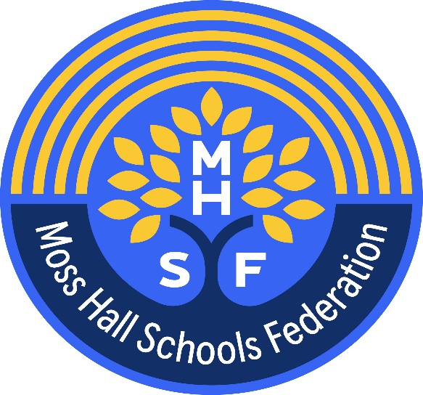

Privacy Notice

How we use parent/carer information – Moss Hall Schools Federation

Moss Hall Infant School – Moss Hall Junior School

The categories of parent/carer information that we collect, hold and share include:
- Personal information (such as name and address)
- Personal information about a parent/carer’s relatives (such as name, contact details, relationship to child)
- Safeguarding referrals and paperwork
- Contact details, contact preferences, date of birth, identification documents
- Results of internal assessments and externally set tests
- Pupil and curricular records
- Characteristics, such as ethnic background, eligibility for free school meals, or special educational needs
- Details of any medical conditions, including physical and mental health
- Attendance information
- Details of any support received, including care packages, plans and support providers
- Data about pupils that we have received from other organisations, including other schools, local authorities and the Department for Education.
- Disability and access requirement
- CCTV, access control video/systems and still photography, for safeguarding if installed on site

Why we collect and use this information
We use the parent/carer data:

- to provide appropriate medical care
- for communication
- to comply with safeguarding regulations
- support pupil learning
- report and monitor pupil progress
- to provide pastoral care
- to ensure and protect pupil welfare
- to assess our services and their quality
- to administer admissions
- to comply with the law regarding data sharing

The lawful basis on which we use this information
We only collect and use pupils’ personal data when the law allows us to. Most commonly, we process it where:
• We need to comply with a legal obligation
• We need it to perform an official task in the public interest
Less commonly, we may also process pupils’ personal data in situations where:
• We have obtained consent to use it in a certain way
• We need to protect the individual’s interests
Where we have obtained consent to use pupils’ personal data, this consent can be withdrawn at any time. We will make this clear when we ask for consent, and explain how consent can be withdrawn.
Some of the reasons listed above for collecting and using pupils’ personal data overlap, and there may be several grounds which allow and justify our use of this data.

We collect and use parent/carer information under
- The Education Act (various years)
- The School Admissions Regulations 2012
- Children and Families Act 2014
- The Special Educational Needs and Disability Regulations 2014
- Article 6, and Article 9 (UK GDPR) (includes special category data)
- Article 23 UK GDPR (Restrictions prevention, investigation and detection of crime)
- Data Protection Act 2018 Schedule 1 paragraph 18 (Individuals at risk)
- Data Protection Act 2018 Schedule 1 paragraph 8 (Equality of opportunity)

The DfE process census data under the various Education Acts – further information can be found on their website: https://www.gov.uk/education/data-collection-and-censuses-for-schools
Collecting parent/carer information
Whilst the majority of parent/carer information you provide to us is mandatory, some of it is provided to us on a voluntary basis. In order to comply with the General Data Protection Regulation, we will inform you whether you are required to provide certain parent/carer information to us or if you have a choice in this.

Storing parent/carer data
We keep personal information about parents and carers of pupils while they are attending our school. We may also keep it beyond their attendance at our school if this is necessary in order to comply with our legal obligations. We keep information about parents and carers of pupils in accordance with the Information and Records Management Society’s retention periods.
For further information please contact the school office, office@mosshalljnr.barnetmail.net

Who we share parent/carer information with
We routinely share parent/carer information with:

- schools that the pupils attend after leaving us
- Moss Hall Infant School
- Moss Hall Junior School
- NHS (Including CAMHS, Social Care, Therapy Providers)
- Local Authority Barnet
- Police
- RM and Google classroom
- cashless systems (Ping – Communications and payments)
- Communication systems (Ping)
- Catering company (The Pantry – Payments and allergies)
- Student assessment companies (e.g.Tapestry,Renaissance,Purple Mash, 2 Simple, White Rose, Wix, Photoface, My maths, Micro Librarian, Educator, Class DoJO, Atomwide)
- FFT Aspire
- Evolve
- My Concern (Child Protection Online Management System)
- Inspire I.T. system
- LGFL
- NHS (Including CAMHS, Social Care, Therapy Providers)
- Student assessment companies (Tapestry)
- Behaviour management - Traffik lights
- Filtering and Monitoring - LGFL WebScreen
- Other companies/people/organisations in reasonable circumstances
- Suppliers and service providers – to enable them to provide the service we have contracted them for

Why we share parent/carer information
We do not share information about our parents/carers with anyone without consent unless the law and our policies allow us to do so.
Police National security, Defence, Public Security,
We share information on request with the Police and Security Services for the prevention investigation and detection of crime (Article 23 UK GDPR)

Transferring data internationally

If we transfer personal data to a country outside the UK, we will do so in accordance with data protection law.

Requesting access to your personal data
Under data protection legislation, parents/carers have the right to request access to information about them that we hold. To make a request for your personal information, contact the office at office@mosshalljnr.barnetmail.net

You also have the right to:
- object to processing of personal data that is likely to cause, or is causing, damage or distress
- prevent processing for the purpose of direct marketing
- object to decisions being taken by automated means
- in certain circumstances, have inaccurate personal data rectified, blocked, erased or destroyed; and
- claim compensation for damages caused by a breach of the Data Protection regulations
If you have a concern or complaint about the way we are collecting or using your personal data, we request that you raise your concern or complaint with us in the first instance. Alternatively, you can contact the Information Commissioner’s Office at https://ico.org.uk/concerns/

Contact
If you would like to discuss anything in this privacy notice, please contact:
David Powell
dpo@sapphireskies.co.uk

