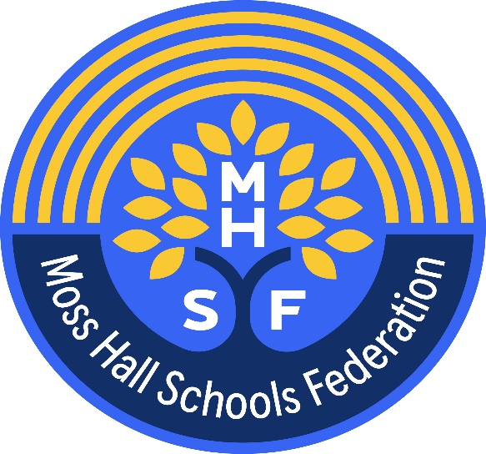

Privacy Notice

How we use pupil information – Moss Hall Schools Federation

Moss Hall Infant School – Moss Hall Junior School

The categories of pupil information that we collect, hold and share include:
- Personal information (such as name, unique pupil number and address)
- Characteristics (such as ethnicity, language, nationality, country of birth and free school meal eligibility)
- Attendance information (such as sessions attended, number of absences and absence reasons)
- Relevant medical information and conditions, including physical and mental health
- Special Education Needs information
- Exclusions/behavioural information
- Personal information about a pupil’s parents and/or other relatives (such as name, contact details, relationship to child)
- Safeguarding referrals and paperwork
- Results of internal assessments and externally set tests
- Pupil and curricular records
- Characteristics, such as ethnic background, eligibility for free school meals, or special educational needs
- Details of any support received, including care packages, plans and support providers
- Data about pupils that we have received from other organisations, including other schools, local authorities and the Department for Education.
- CCTV, access control video/systems and still photography, for safeguarding if installed on site

Why we collect and use this information
We use the pupil data:

- To support pupil learning
- To monitor and report on pupil progress
- To provide appropriate pastoral care
- To assess the quality of our services
- Administer admissions waiting lists
- To comply with the law regarding data sharing
- To share data for statutory inspections and audit purposes
- To report pupil progress and attainment

The lawful basis on which we use this information
We only collect and use pupils’ personal data when the law allows us to. Most commonly, we process it where:
• We need to comply with a legal obligation
• We need it to perform an official task in the public interest
Less commonly, we may also process pupils’ personal data in situations where:
• We have obtained consent to use it in a certain way
• We need to protect the individual’s interests
Where we have obtained consent to use pupils’ personal data, this consent can be withdrawn at any time. We will make this clear when we ask for consent and explain how consent can be withdrawn.
Some of the reasons listed above for collecting and using pupils’ personal data overlap, and there may be several grounds which allow and justify our use of this data.

We collect and use pupil information under:
- The Education Act (various years)
- The Education (Pupil Registration) (England) Regulations
- The School Standards and Framework Act 1998
- The School Admissions Regulations 2012
- Children and Families Act 2014
- The Special Educational Needs and Disability Regulations 2014
- Article 6, and Article 9 (UK GDPR) (includes special category data)
- Article 23 UK GDPR (Restrictions prevention, investigation and detection of crime)
- Data Protection Act 2018 Schedule 1 Paragraph 18 (Individuals at risk)
- Data Protection Act 2018 Schedule 1 paragraph 8 (Equality of opportunity)

The DfE process census data under the various Education Acts – further information can be found on their website: https://www.gov.uk/education/data-collection-and-censuses-for-schools
Collecting pupil information
Whilst the majority of pupil information you provide to us is mandatory, some of it is provided to us on a voluntary basis. In order to comply with the UK General Data Protection Regulation, we will inform you whether you are required to provide certain pupil information to us or if you have a choice in this.

Storing pupil data
We keep personal information about pupils while they are attending our school. We may also keep it beyond their attendance at our school if this is necessary in order to comply with our legal obligations. We keep information about pupils in accordance with the Information and Records Management Society’s retention periods..
For further information please contact the school office, office@mosshalljnr.barnetmail.net

Who we share pupil information with
We do not share information about pupils with any third party without consent unless the law and our policies allow us to do so. Where it is necessary or legally required and it complies with data protection law we may share personal information about pupils with:

- The Local Authority – Barnet
- Moss Hall Infant School
- Moss Hall Junior School
- Department for Education
- Ofsted
- School Pupil Tracker Online (cloud based pupil assessment tracker)
- The Pantry – School meals and allergies- (online parent payment system)
- Communications and Payments –(Ping)
- RM Integris (school management database system)
- School Nurse (where appropriate) schools that the pupils attend after leaving us
- NHS (Including CAMHS, Social Care, Therapy Providers)
- Police, courts and tribunals
- Google classroom
- Student assessment companies (e.g.Tapestry,Renaissance,Purple Mash, 2 Simple, White Rose, Wix, Photoface, My maths, Micro Librarian, Educator, Class DoJO, Atomwide, Insight, Tapestry)
- Behaviour management – (Traffik Light)
- FFT Aspire
- Evolve
- My Concern (Child Protection Online Management System)
- IT provider Inspire IT
- LGFL
- WONDE
- Catering company (The Pantry)
- Schools that the pupils attend after leaving us
- the Department for Education (DfE)
- Pupil’s family and representatives
- Educators and examining bodies,
- Suppliers and service providers – to enable them to provide the service we have contracted them for
- Financial organisations
- Central and local government
- Our auditors
- Survey and research organisations
- Atomwide
- School Photos and videos
- Bikeability
- Filtering and Monitoring - LGFL WebScreen
- Other companies/people/organisations in reasonable circumstances

Why we share pupil information
We do not share information about our pupils with anyone without consent unless the law and our policies allow us to do so.
We share pupils’ data with the Department for Education (DfE) on a statutory basis. This data sharing underpins school funding and educational attainment policy and monitoring.
We are required to share information about our pupils with our local authority (LA) and the Department for Education (DfE) under section 3 of The Education (Information About Individual Pupils) (England) Regulations 2013.
Police National security, Defence, Public Security,
We share information on request with the Police and Security Services for the prevention investigation and detection of crime (Article 23 UK GDPR)

Data collection requirements:
To find out more about the data collection requirements placed on us by the Department for Education (for example; via the school census) go to https://www.gov.uk/education/data-collection-and-censuses-for-schools.

The National Pupil Database (NPD)
The NPD is owned and managed by the Department for Education and contains information about pupils in schools in England. It provides invaluable evidence on educational performance to inform independent research, as well as studies commissioned by the Department. It is held in electronic format for statistical purposes. This information is securely collected from a range of sources including schools, local authorities and awarding bodies.
We are required by law, to provide information about our pupils to the DfE as part of statutory data collections such as the school census and early years’ census. Some of this information is then stored in the NPD. The law that allows this is the Education (Information About Individual Pupils) (England) Regulations 2013.
To find out more about the NPD, go to https://www.gov.uk/government/publications/national-pupil-database-user-guide-and-supporting-information.

The department may share information about our pupils from the NPD with third parties who promote the education or well-being of children in England by:
- conducting research or analysis
- producing statistics
- providing information, advice or guidance
The Department has robust processes in place to ensure the confidentiality of our data is maintained and there are stringent controls in place regarding access and use of the data. Decisions on whether DfE releases data to third parties are subject to a strict approval process and based on a detailed assessment of:
- who is requesting the data
- the purpose for which it is required
- the level and sensitivity of data requested: and
- the arrangements in place to store and handle the data
To be granted access to pupil information, organisations must comply with strict terms and conditions covering the confidentiality and handling of the data, security arrangements and retention and use of the data.
For more information about the department’s data sharing process, please visit: https://www.gov.uk/data-protection-how-we-collect-and-share-research-data
For information about which organisations the department has provided pupil information, (and for which project), please visit the following website: https://www.gov.uk/government/publications/national-pupil-database-requests-received

To contact DfE: https://www.gov.uk/contact-dfe

Transferring data internationally

If we transfer personal data to a country outside the UK, we will do so in accordance with data protection law.

Requesting access to your personal data
Under data protection legislation, parents and pupils have the right to request access to information about them that we hold. To make a request for your personal information, or be given access to your child’s educational record, contact the office at office@mosshalljnr.barnetmail.net

You also have the right to:
- object to processing of personal data that is likely to cause, or is causing, damage or distress
- prevent processing for the purpose of direct marketing
- object to decisions being taken by automated means
- in certain circumstances, have inaccurate personal data rectified, blocked, erased or destroyed; and
- claim compensation for damages caused by a breach of the Data Protection regulations
If you have a concern or a complaint about the way we are collecting or using your personal data, we request that you raise your concern or complaint with us in the first instance. Alternatively, you can contact the Information Commissioner’s Office at https://ico.org.uk/concerns/

Contact
If you would like to discuss anything in this privacy notice, please contact:
David Powell
dpo@sapphireskies.co.uk

