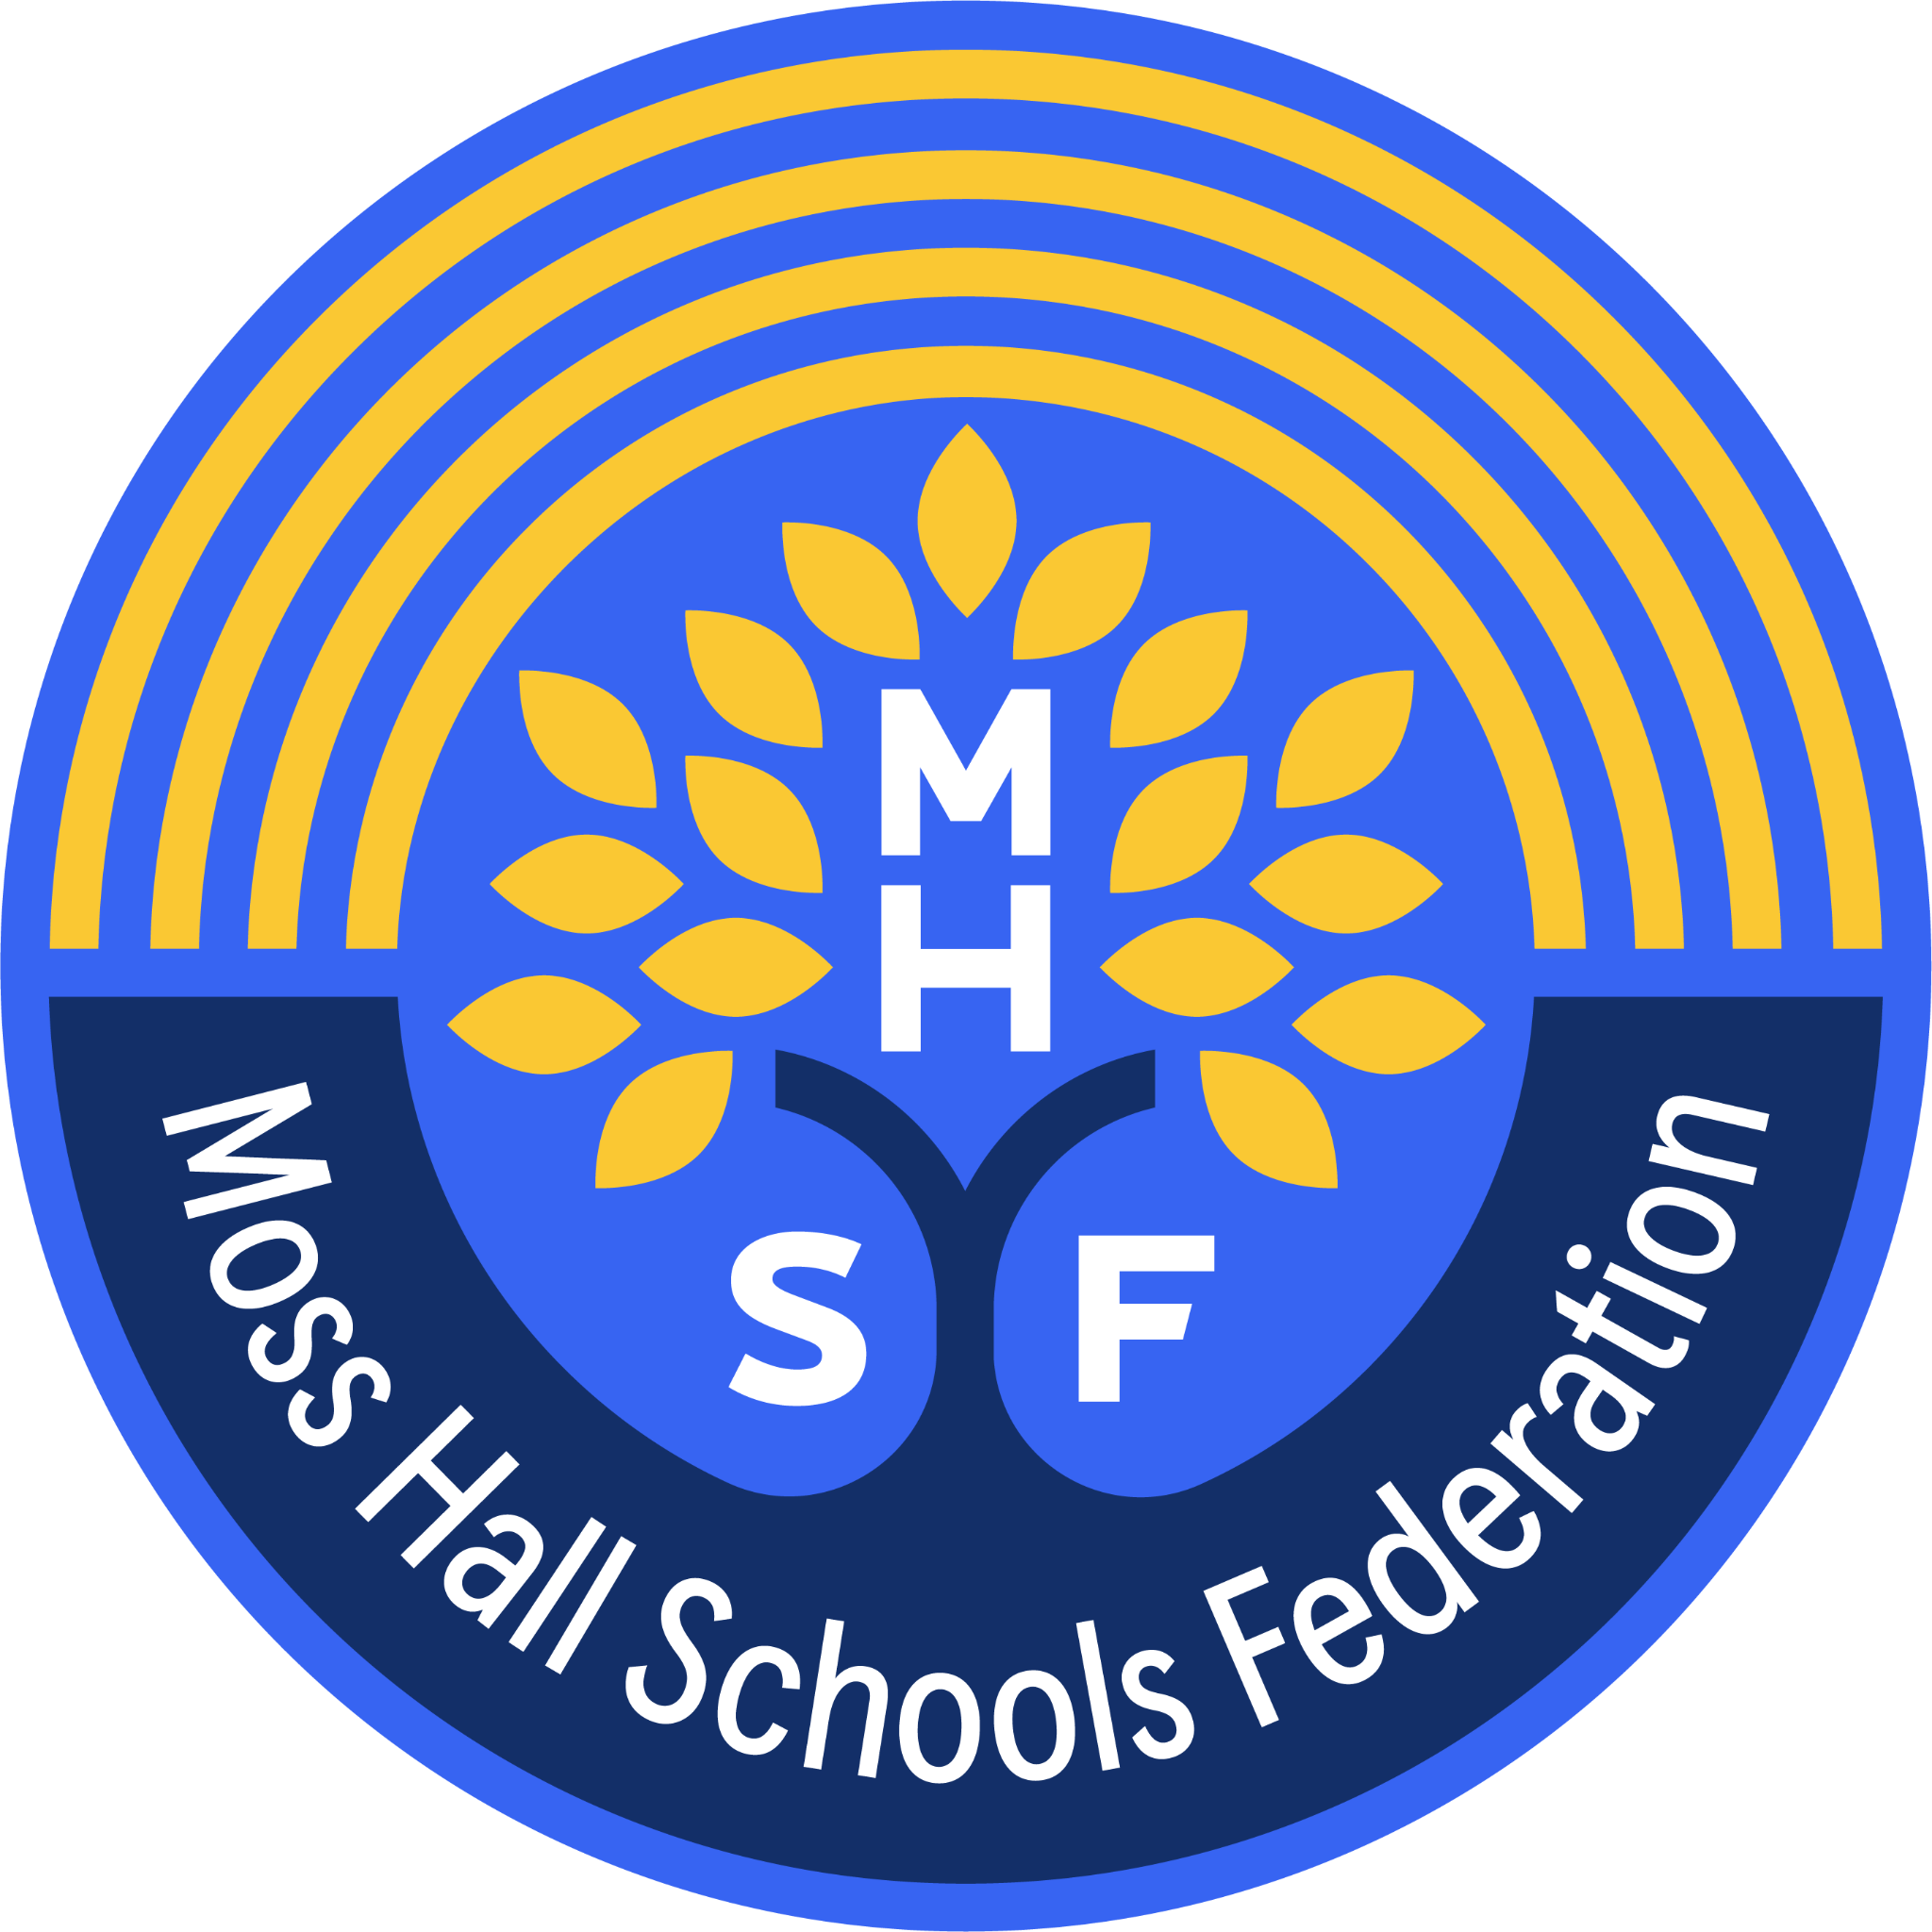
Moss Hall Schools Federation
Federation Teaching Assistant - Level 2 – Special Educational Needs Assistant

Start Date: 1st September 2024
Pay Range: Level 2 Grade D (£28,272-29,583 FTE pro-rata)
Contract: 2 year contract. Potential to extend permanently following successful probationary period
Hours: 31 ¼ hrs/week: Term Time only:

At Moss Hall Schools Federation, our aim is for every child to thrive. We value kindness and hard work so that we all make a positive difference in our school and community. You will be joining a federation of 2 schools, Moss Hall Infant and Moss Hall Junior Schools who serve our inclusive and diverse West Finchley community.

We’re looking for colleagues to join us who:
- Are ambitious for every child in our schools
- are interested in how young children learn and genuinely motivated to instill these approaches
- Have an energetic, positive “can-do” attitude with the ability to inspire and motivate our children
- Have experience of supporting young children who have a range of special educational needs

We offer the successful candidates:
- Children who love their school and love learning
- An ambitious curriculum that is accessible for all children
- CPD and training and career development opportunities

We have roles with our infant and our junior age children. The appointed post-holder will be expected to work on-site and flexibly according to the needs of the school. For more information including the application pack visit our website www.mosshall.school

Safeguarding
Moss Hall Schools Federation and its staff are committed to safeguarding the welfare of children. The School is registered with the DBS and successful applicants will be required to successfully complete the Disclosure procedure at the Enhanced level. It is an offence for any person barred from working with children to apply for this post.
The School’s Application Form will only be accepted from candidates who have completed this form in full. CV’s will not be accepted as a substitute.
In addition to completing an application form, all applicants will be required to complete a criminal records self-declaration form. Please note you are not required to disclose convictions or cautions that are ‘protected’, as defined by the Rehabilitation of Offenders Act 1974 (Exceptions) Order 1975 (as amended in 2013). If you have a conviction and are not sure whether is it ‘protected’, please visit the Gov.UK link below:
https://www.gov.uk/tell-employer-or-college-about-criminal-record/check-your-conviction-caution
The safeguarding responsibilities of this post have been outlined in the job description and person specification.
Moss Hall Schools Federation is committed to Equal Opportunities and welcomes applications from all sections of the community.

We strongly recommend that you visit the federation prior to applying. To do so or if you have any queries, please contact our Federation Business Manager, Toral Patel.

We are ideally located and within walking distance of West Finchley underground station and popular bus routes. There is free off-street parking nearby.
We strongly recommend that you visit or talk to a member of the leadership team prior to applying. To make an appointment or if you have any queries, please contact Haleh Honarzad via recruitment@mhi.org.uk

Completed application forms should be sent to Ms Honarzad c/o recruitment@mhi.org.uk by 5pm on Thursday 20th June
Shortlisting from: 21st June 2024
Selection tasks and interview date: Thursday 27th June 2024

The school reserves the right to close the vacancy earlier than the date advertised, so early application is advised. Previous applicants and employees need not apply.

